FINAL CONCLUSION
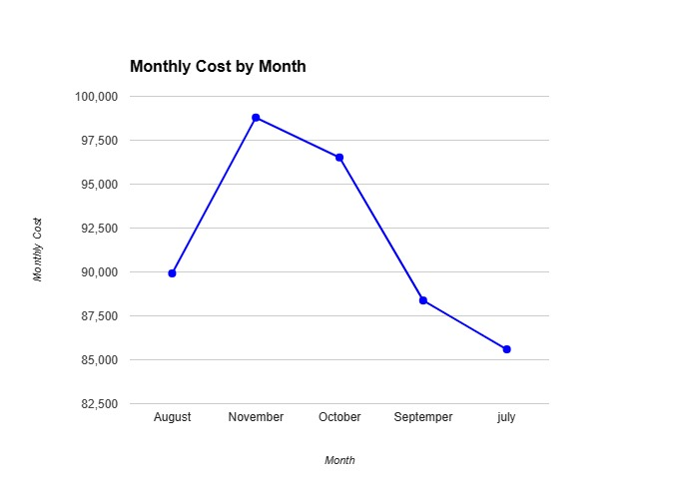
Total Cost Of Electric Consumption In The Past Five Months

Key Observations:
- Overall Trend: The electric consumption costs exhibit an upward trend from July to November, suggesting an increase in usage or potential rate changes.
- Highest Cost Month: November has the highest cost at 98791.09, potentially indicating more energy-intensive activities or seasonal factors.
- Lowest Cost Month: July has the lowest cost at 85594.15, possibly reflecting reduced usage patterns or milder weather conditions.
- Cost Variation: The costs range from 85594.15 to 98791.09, demonstrating a difference of 13196.94 between the highest and lowest months.
- Recent Increase: Costs have notably increased in the last three months (August, October, November), which could warrant further investigation.
Potential Insights:
- Seasonal Impact: The increase in costs from July to November might suggest a relationship with seasonal changes in temperature or energy-use patterns.
- Usage Patterns: Understanding the specific activities or appliances contributing to higher consumption in certain months could inform energy-saving strategies.
- Rate Changes: It's worth checking for any rate adjustments that might have impacted costs, especially if the increase is unexpected.
Recommendations:
- Further Analysis: Consider examining historical data for trends and potential correlations with factors like weather or usage patterns.
- Explore Energy Efficiency: Investigate opportunities to reduce consumption through behavioral changes or energy-efficient technologies.
- Monitor Usage: Regularly track consumption to identify anomalies and take proactive measures to manage costs.

